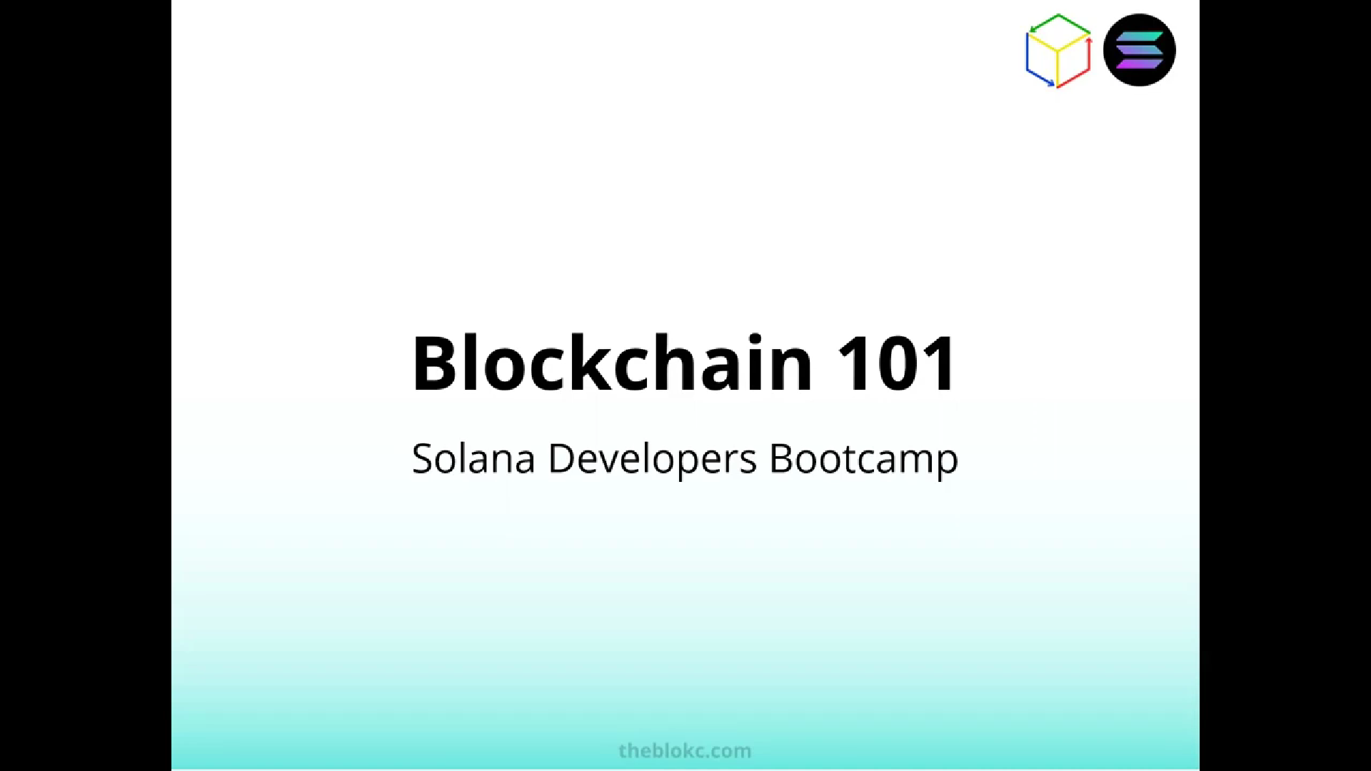

Blockchain is the underlying technology of #cryptocurrencies and is expected to decentralize the world in almost all areas: finance, supply chain tracking, InternetOfThings, DigitalTwins and NFTs.

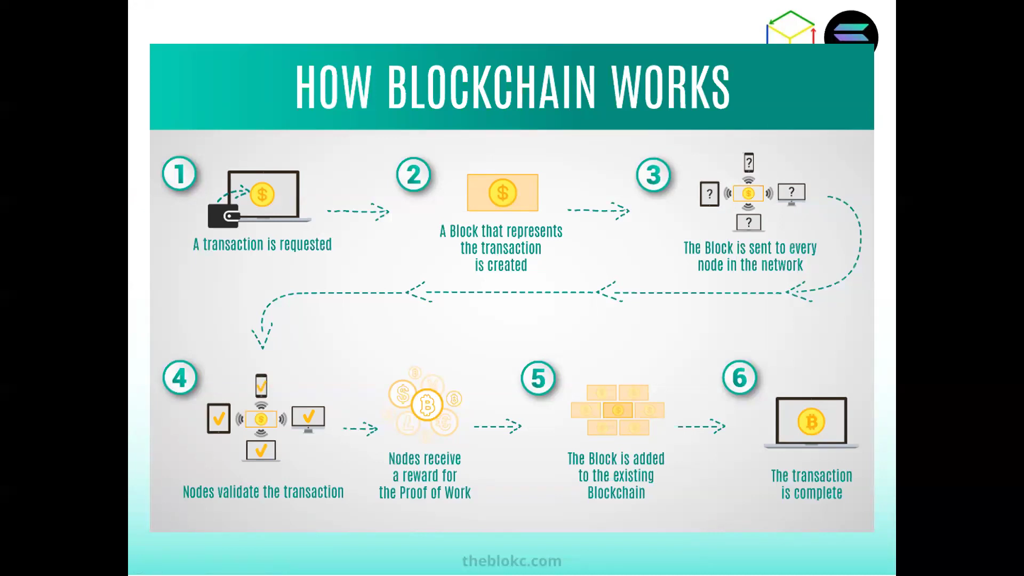

***Macroscopic View of how blockchain works***

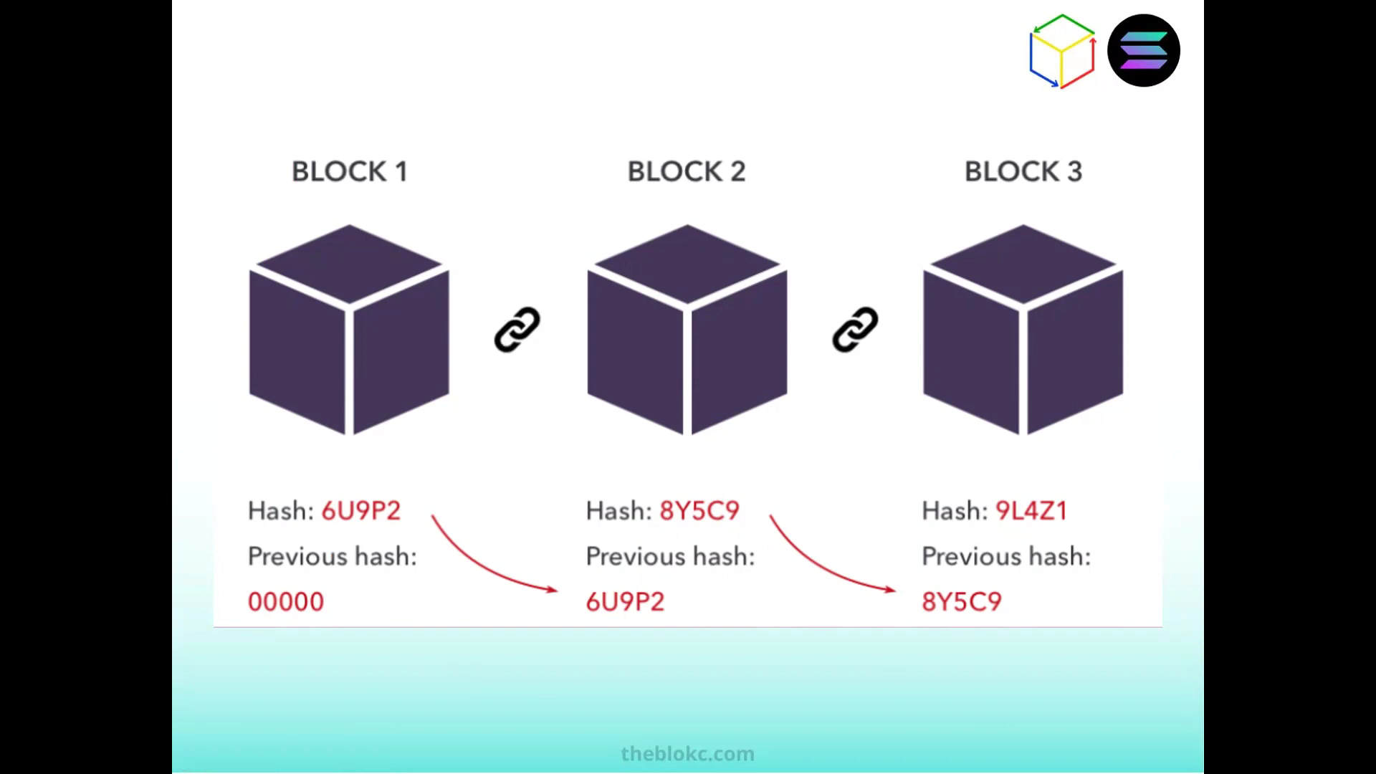***Microscopic View of how blockchain works***

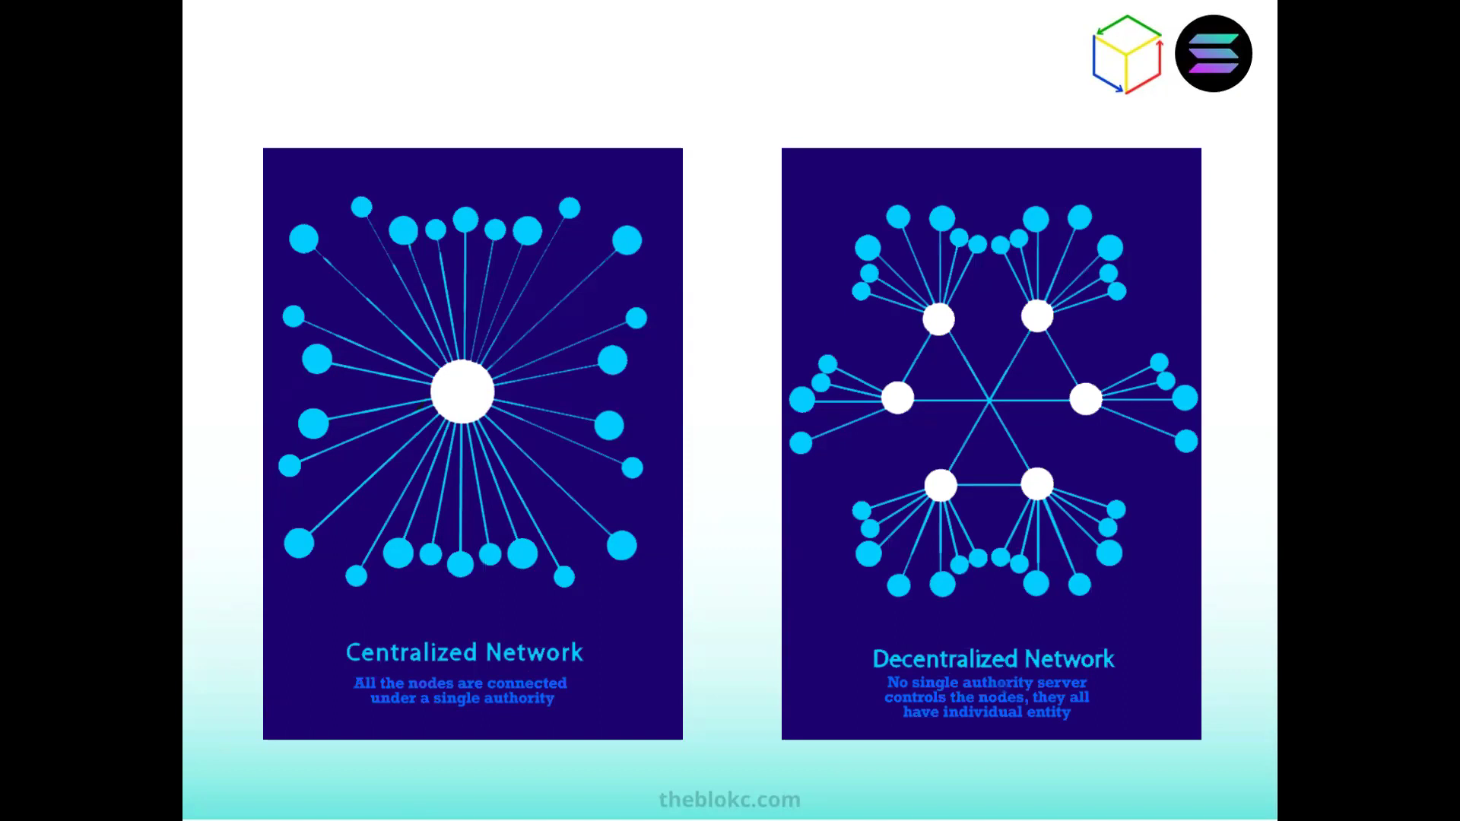

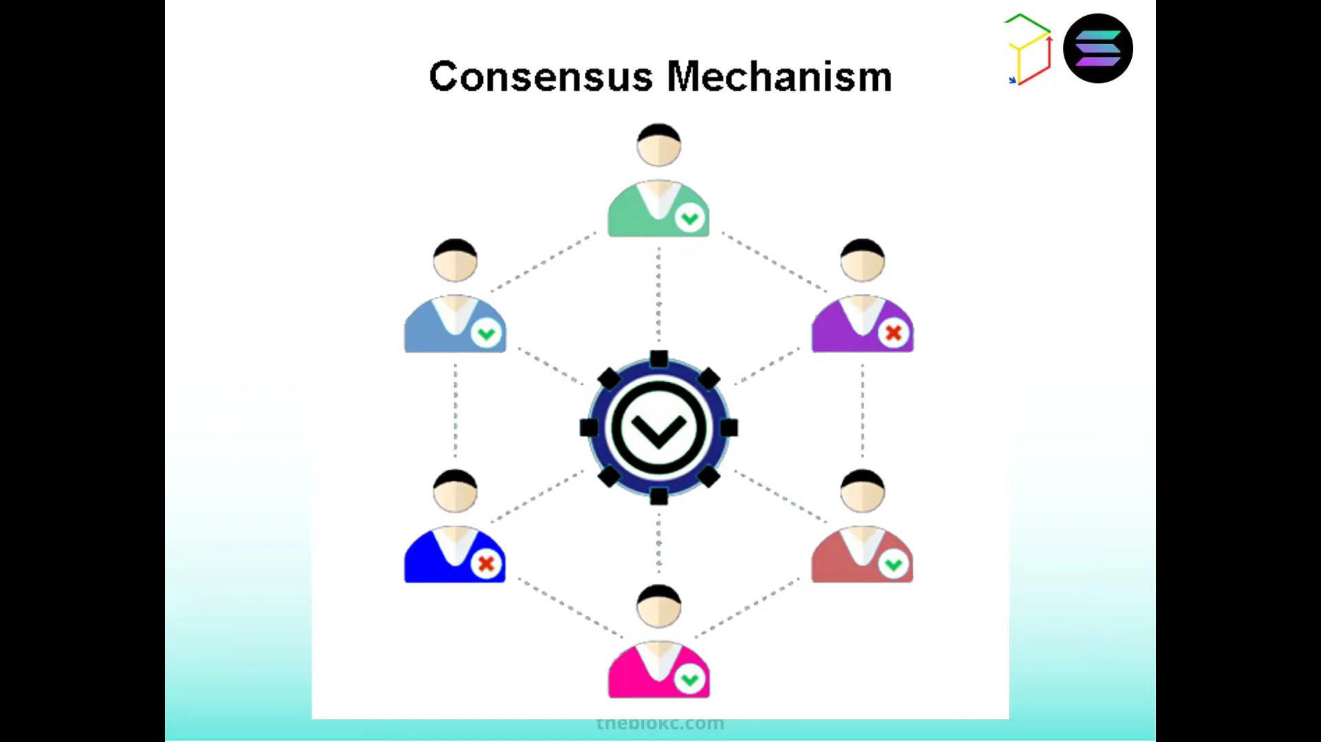

Consensus mechanism maintains order in the blockchain.

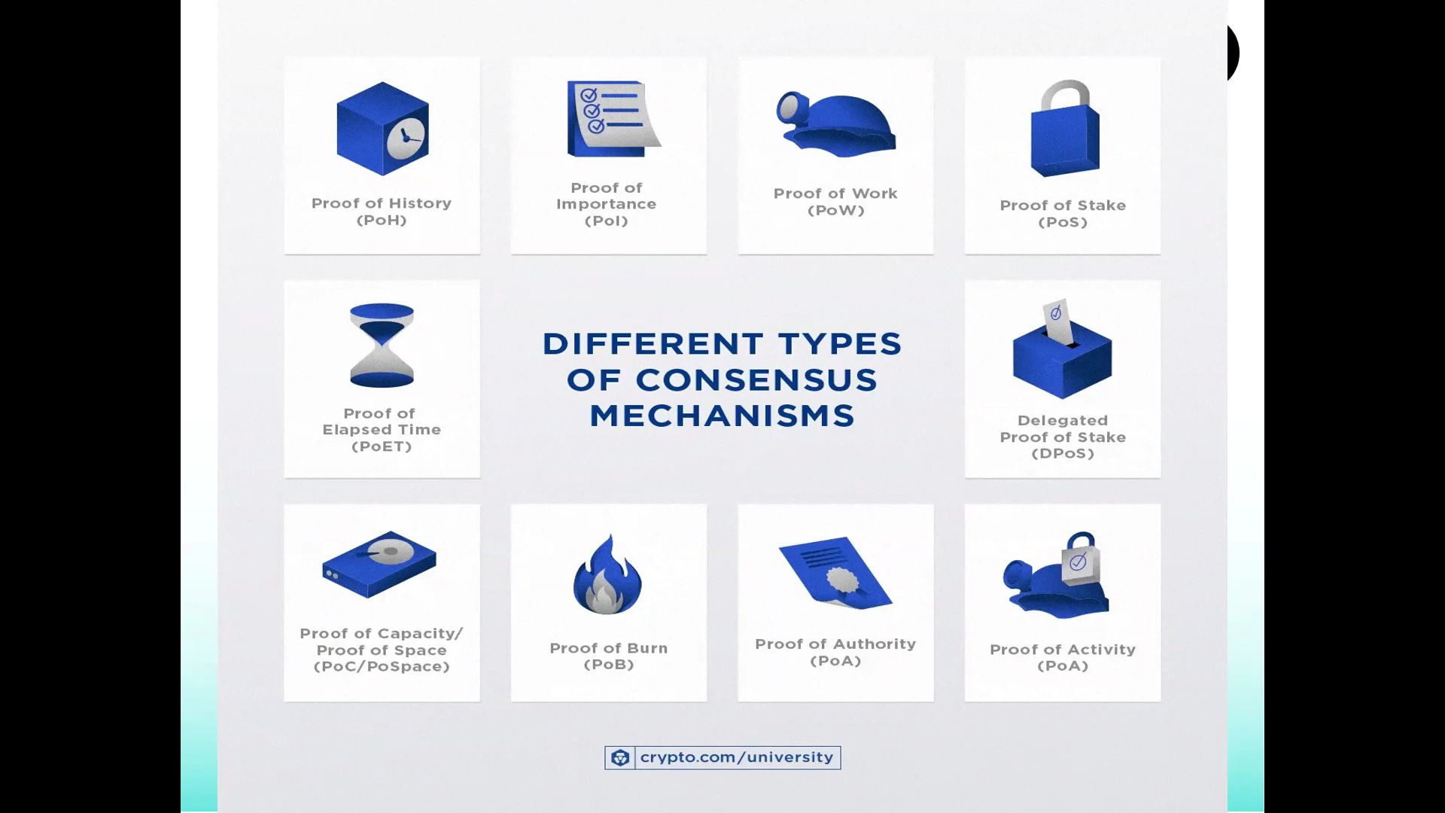

All proofs are derived from Proof of Work and Stake

Proof of Work (used in Bitcoin and cryptomining)

Proof of History (used by Solana)

Proof of Stake (used by eterium)

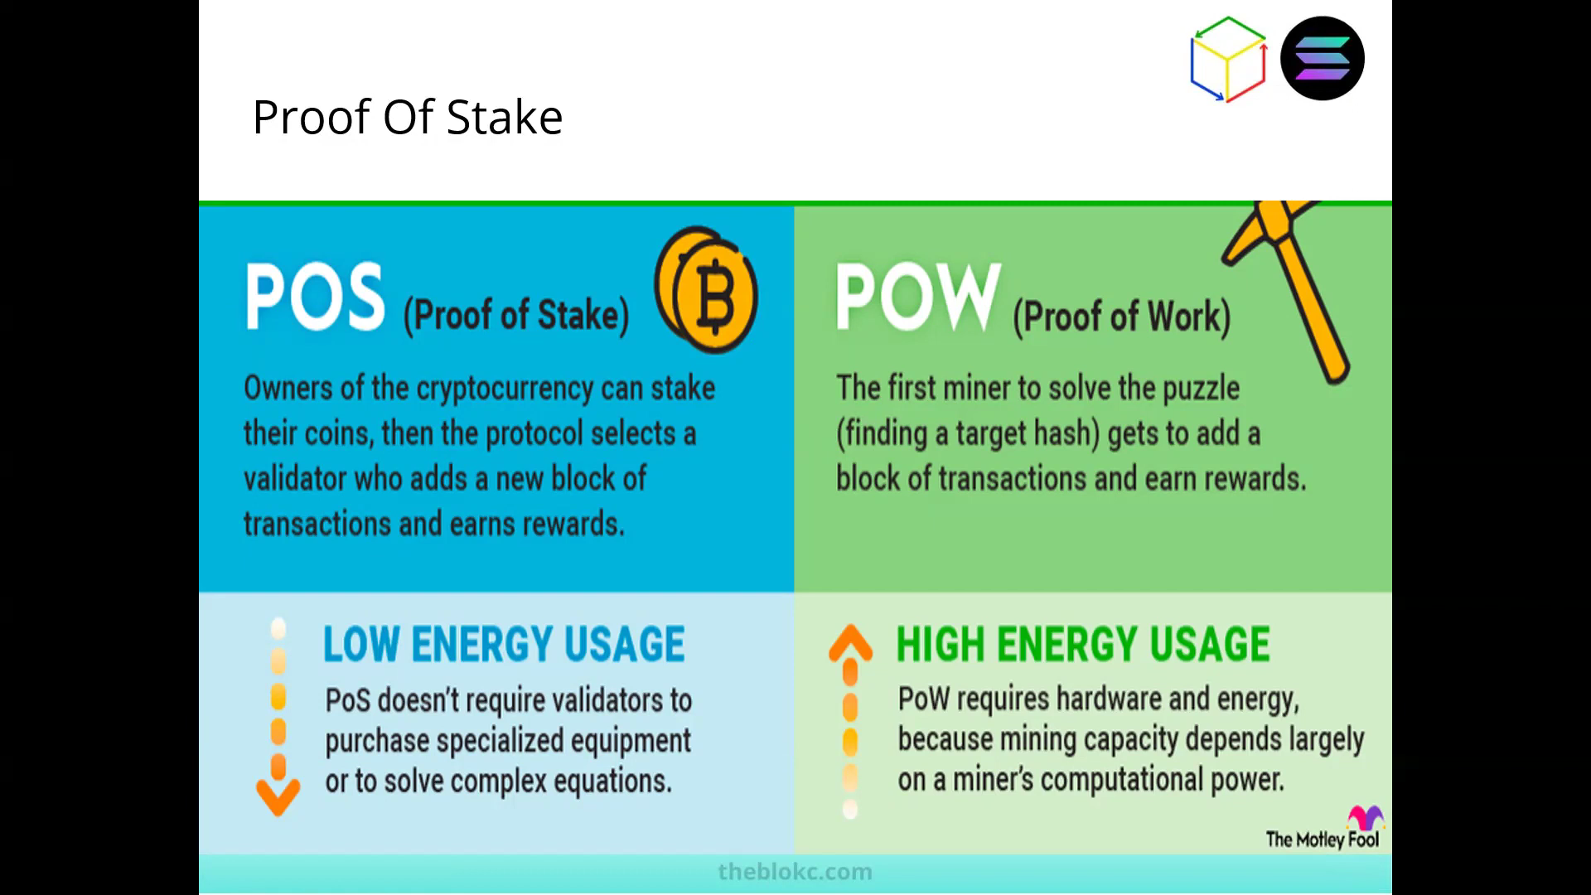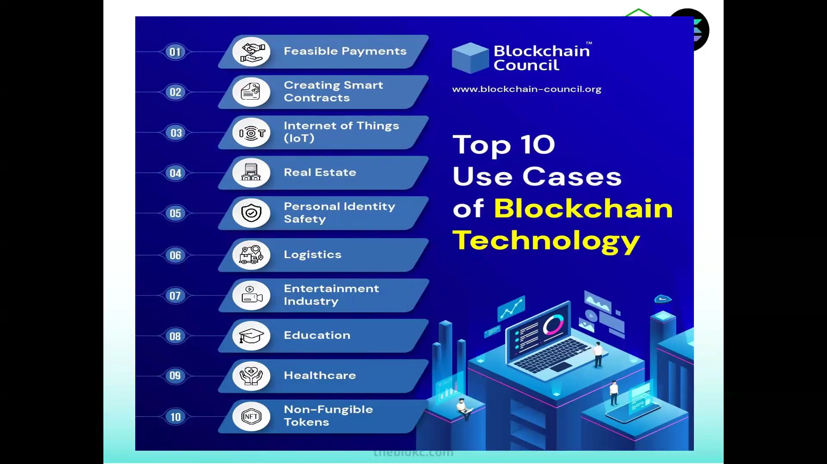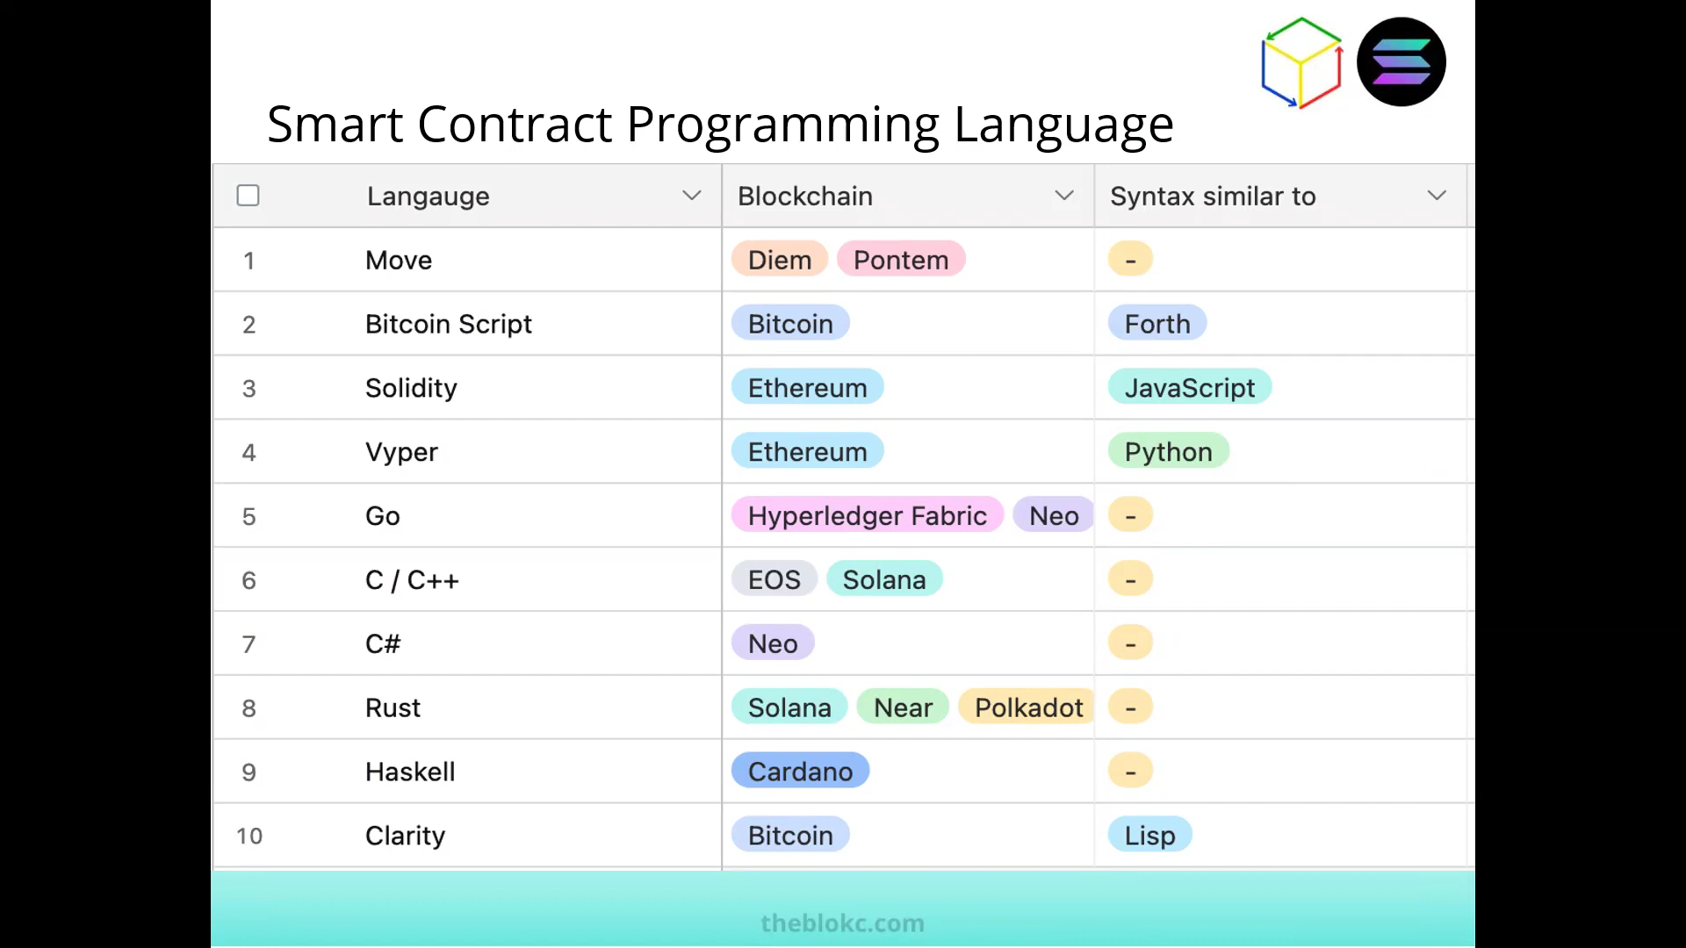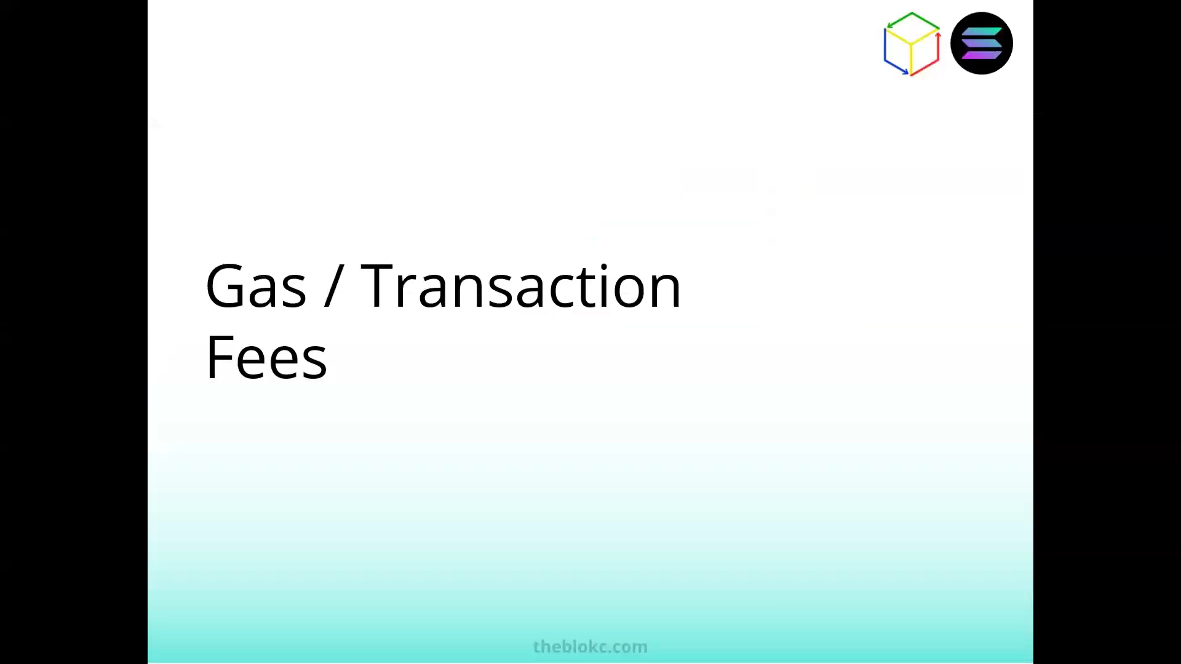

*Processing transactions, I.e., running smart contracts, generate gas fees in the network.*

*Essential for sustaining the blockchain*

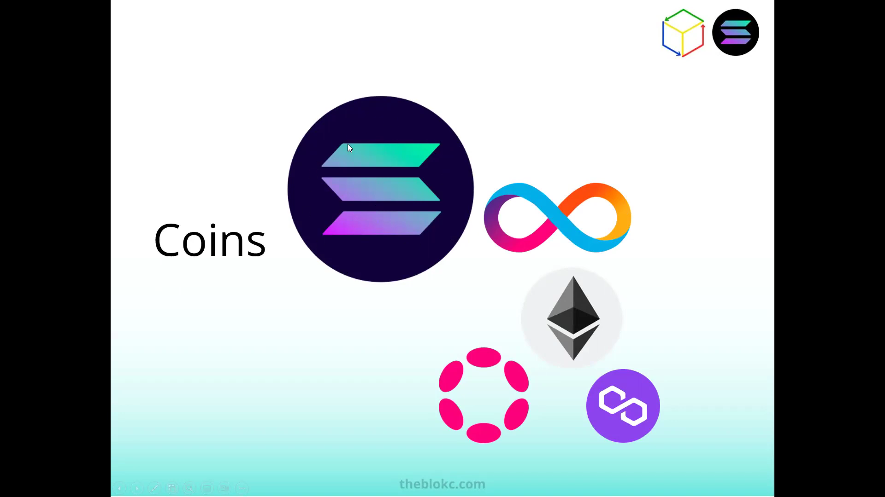

Assignment answer (purple logo)

**Matic Coin by Polygon**

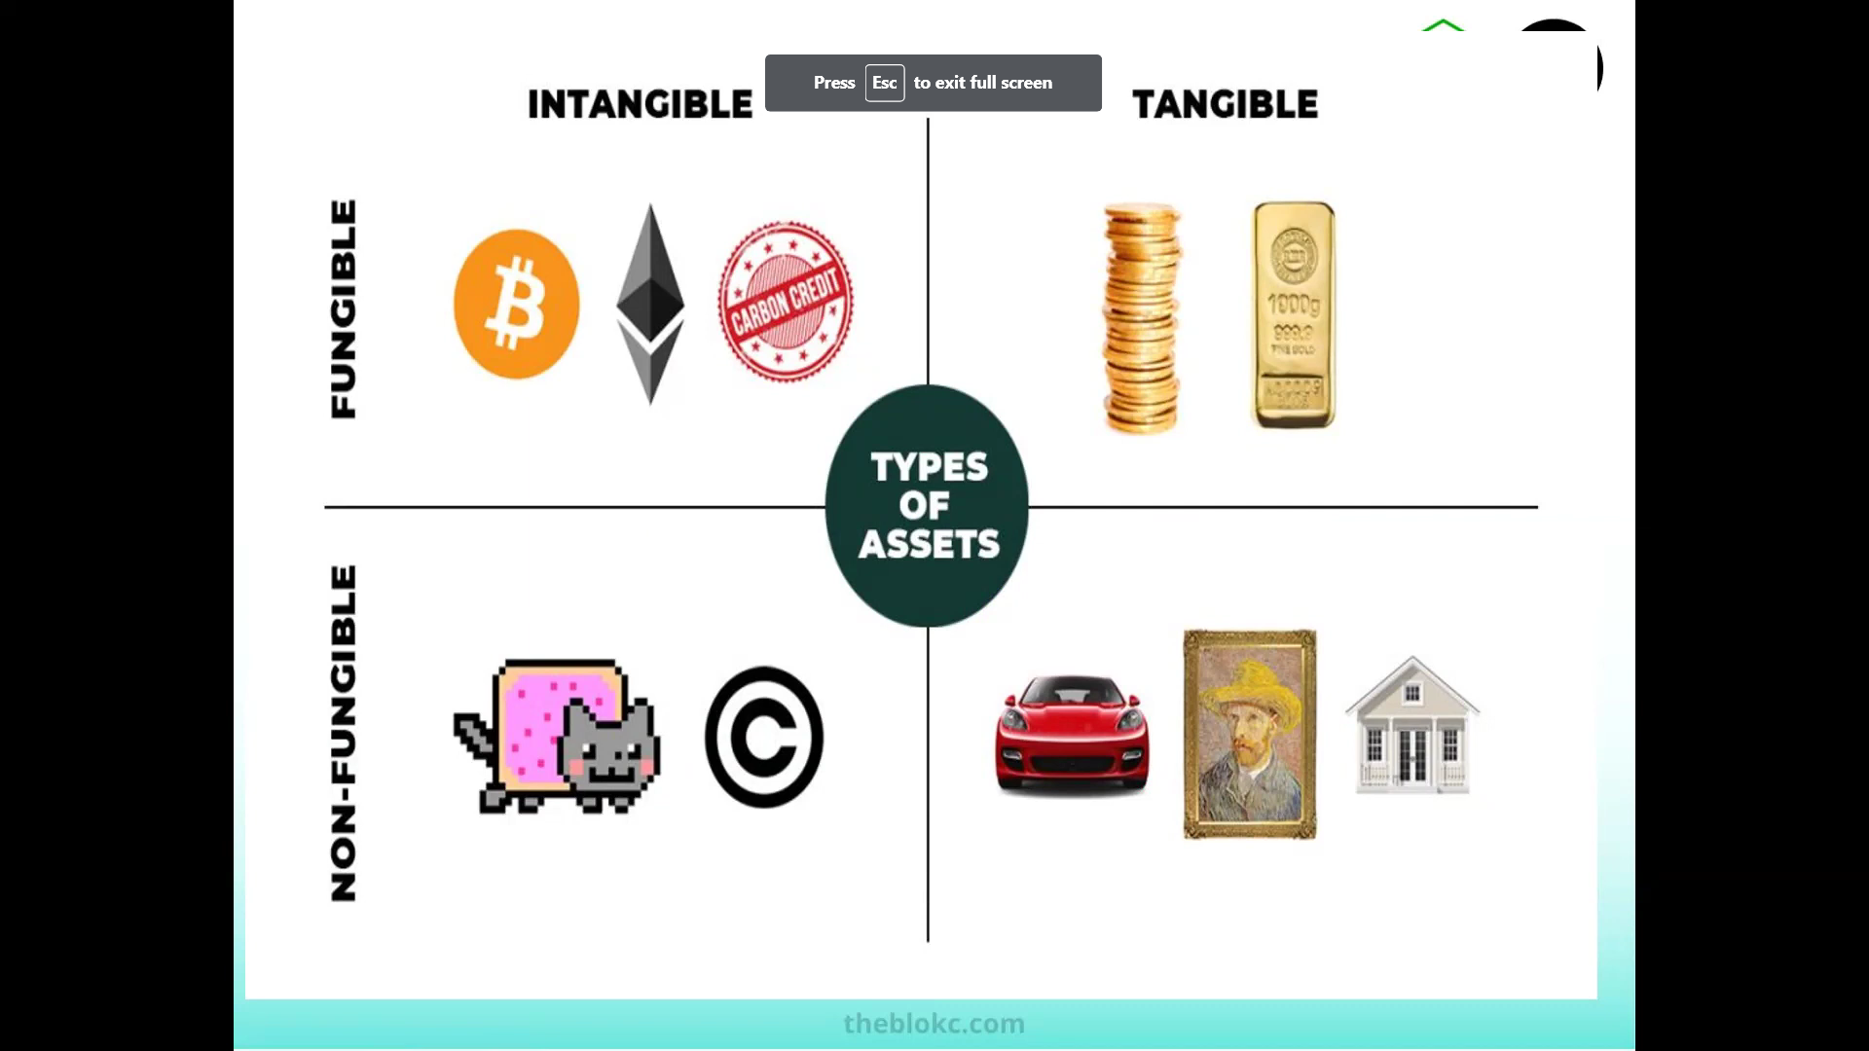

Fungible = interchangeable with standardized price points

Non-fungible = not interchangeable with each item and price points unique

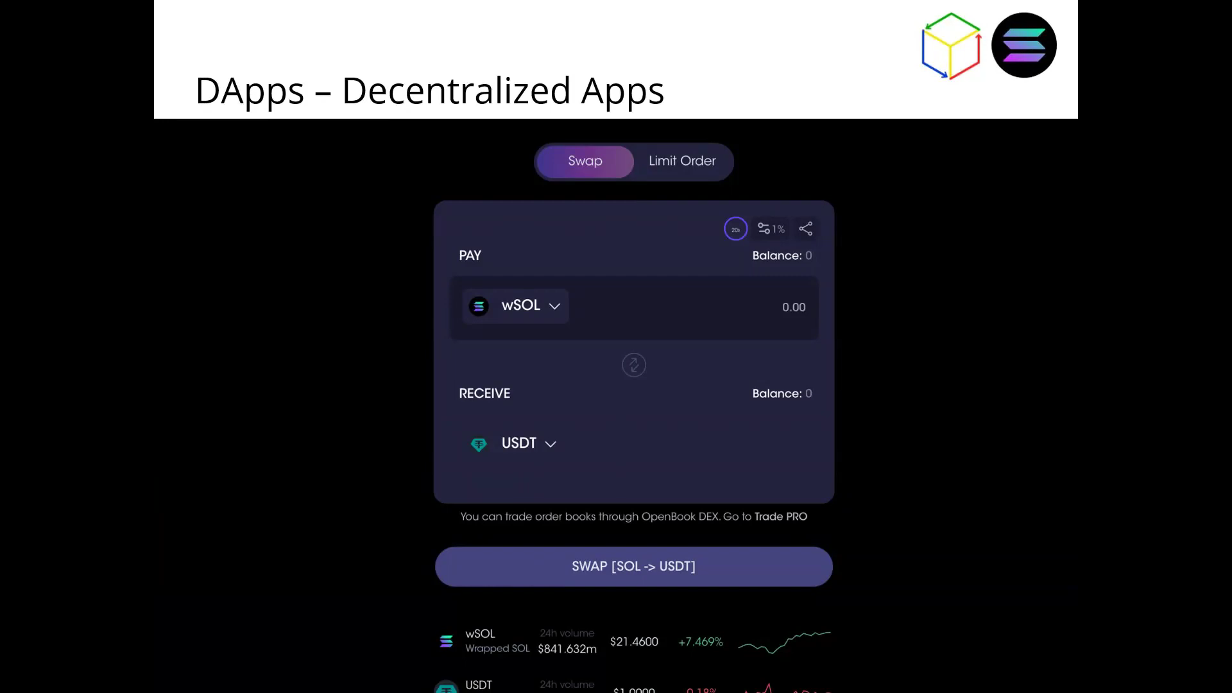

Final requirement^^